Annex L. Baseline report on demonstration landscapes

Project: Participatory in-situ conservation and sustainable use of agrobiodiversity in Hainan
UNDP PIMS: 5823 | GEF Project ID: TBD

Introduction
This document presents profiles of three agricultural demonstration landscapes, having a cumulative area of 13,787 ha, situated in Hainan province where the project will engage farmers in the conservation and sustainable use of agrobiodiversity.
Target GRFA variety | County / Township | Agricultural Landscape
Target GRFA variety | County / Township | Mid-point Georeferenced Coordinates |  | Area, ha | No. Households | Est. Direct Beneficiaries | No. HHs engaged in GRFA variety
Target GRFA variety | County / Township | Longitude | Latitude
Wuzhishan pig  (Bos taurus) | Baisha/  Da’an | 109º15’ | 19º10’ | 1,328 | 329 | 1.316 | 36
Shanlan rice  (Oryza sativa) | Qiongzhong/  Shang’an | 109º48’ | 18º53’ | 11,140 | 334 | 1,336 | 5
Jiaji duck  (Cairna oschata) | Qionghai/  Shibi | 110º18’ | 19º09’ | 1,319 | 690 | 2,760 | 5
Total: |  |  |  | 13,787 | 1,353 | 5,412 | 46
Note: Estimated direct beneficiaries based upon assumption of an average of 4 persons per household (HH).
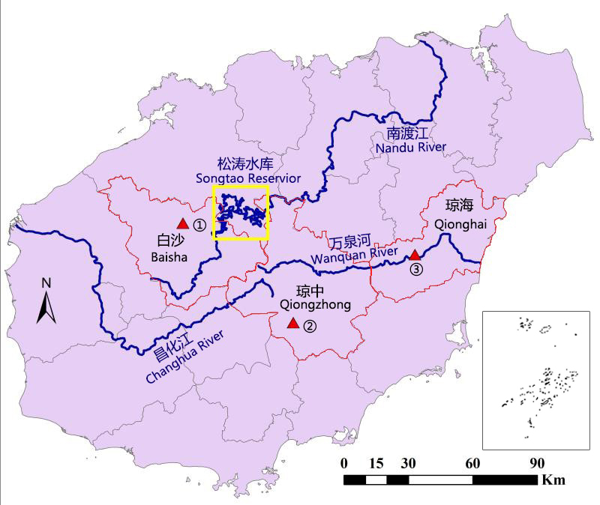
Figure L-1: Province map
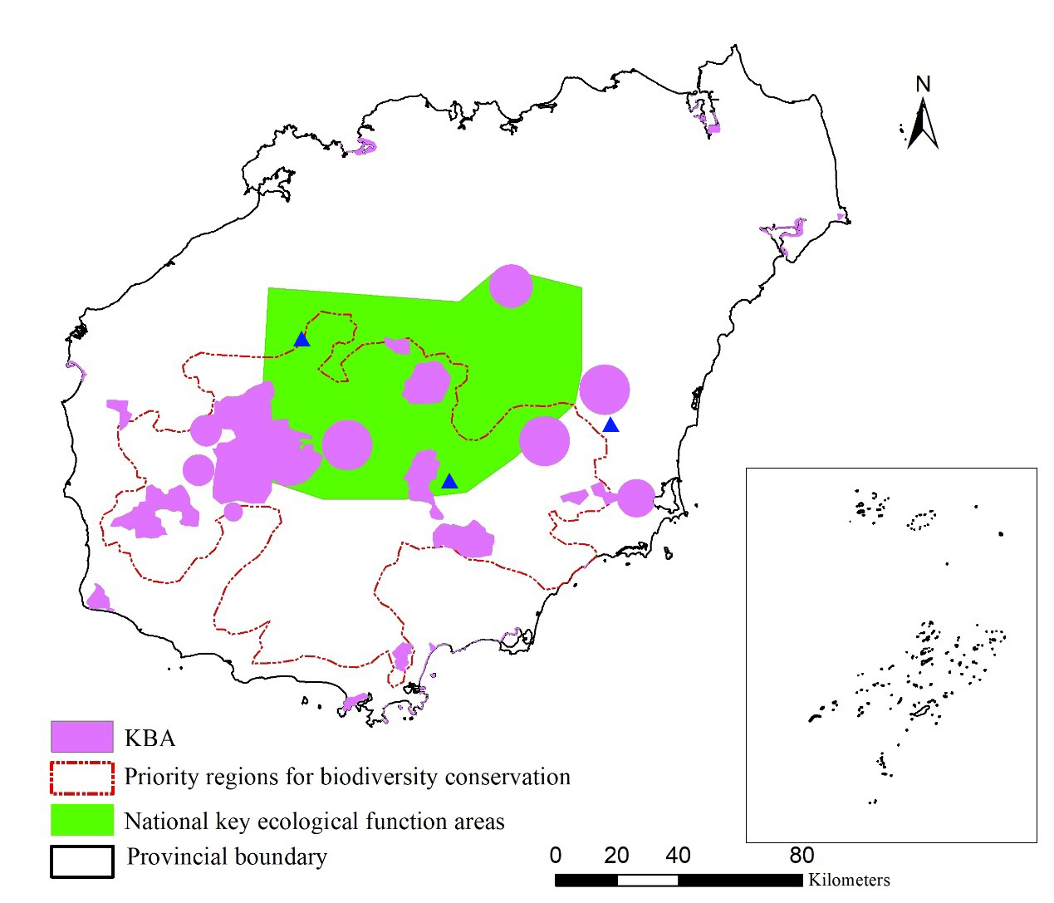
Figure L-2: Significant biodiversity areas in the province

Shanlan rice landscape profile

Physical Setting
The demonstration landscape for Shanlan rice is located in the Shang’an Township (see Figure L-3). The demonstration landscape covers an area of 11,140 ha, as shown on Figures L-4. The landscape was delineated on the basis of habitat suitability and traditional knowledge for cultivating this variety of rice in the township.
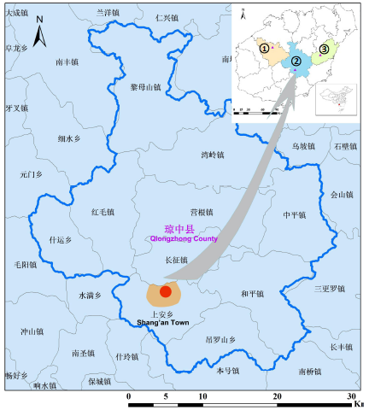
Figure L-3: Location map of Shanlan rice demonstration landscape
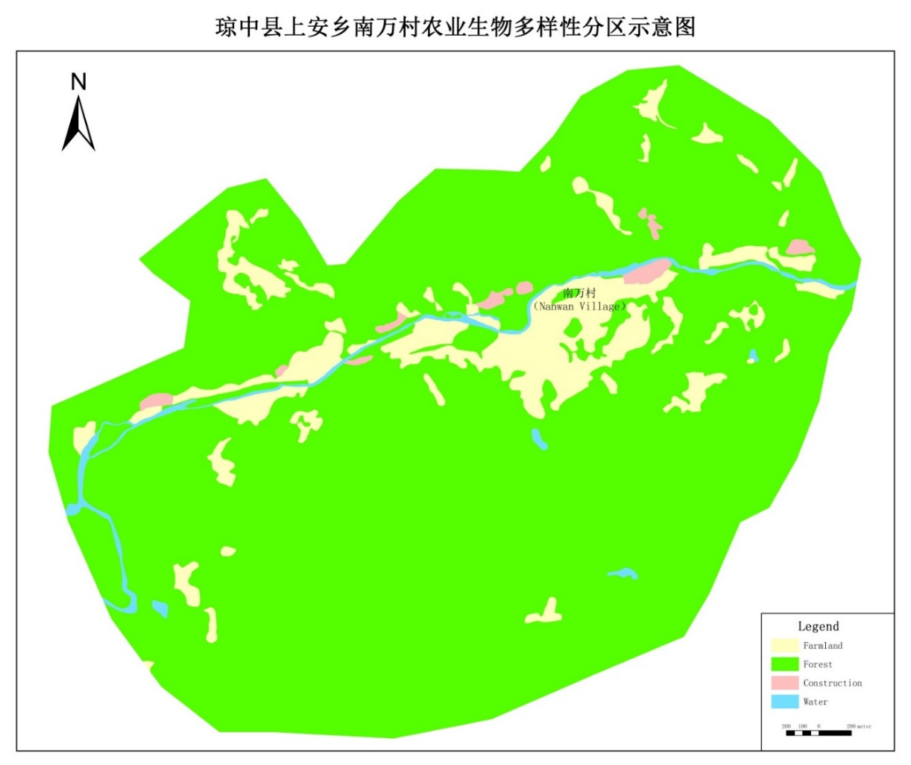
Figure L-4: Demonstration landscape map, Shanlan rice
Shang’an Township is located in the mountainous area of central Hainan, in the south part of Qiongzhong County. Nanwan village is at north side of the township, neighboring Changzheng Township. The terrain is mainly mountainous and hilly. The highest point is located in the Wuzhishan National Nature Reserve, and the highest peak is 1,867 meters above sea level.
Shang’an Township has a rubber planting area of 596.066 ha, betel nut area of 672 ha, coconut 51.53 ha, grass buckle of 16.87 ha, litchi 351.73 ha, longan 362.07 ha, green orange planting area of 40.53 ha, cassava 187.4 ha and other economic crops. The township's gross domestic product was CNY 3.3 million (approx. USD 480,000) in 2016, of which the total output value of township enterprises was CNY 1,816,700 (approx. USD 265,000) , an increase of 8.3 % over the previous year, and the per capita net income was CNY 1,426 (approx. USD 207) , an increase of CNY 169 (approx. USD 25) over previous year. Shangan Township has a tropical marine monsoon climate, with an average annual temperature of 22.8 °C, the hottest month is July, when the average annual temperature is 26.8 °C, the coldest month is January, the average annual temperature is 17.2 °C, and the annual rainfall is 2400-2500 mm. Typhoons and other catastrophic weather can occur, with characteristic strong winds and heavy rain. Winter and spring droughts have an impact on agricultural production. The Shangan Township is situated in the upper reaches of the Wanquan River. The main tributary rivers to the Wanquan are the Nanshi River, the Zhaoyi River, and the Shiyu River. The region is rich in mineral resources, including gold and granite.

Diversity Status, Threats, Coverage and Nutritional and Cultural Values
There is no exact written history of when people originally cultivated Shanlan rice. The earliest record of Shanlan rice cultivation was in Qiongtai Chronicle (琼台志), which was authored by Tang Zhou during Zhengde Time (1506-1521 AD) in Ming Dynasty ³. Shanlan rice is a type of highland rice, which can be classified under the species of Oryza sativa. In the agricultural practices, Li people on Hainan Island developed a unique system of farming system, including the germplasm conservation, cultivation techniques, processing and consuming custom for Shanlan rice. As a result of hundreds of years of farming, fruitful sources of Shanland rice germplasms have been formed. In 1992, Wang Guanyuan studied 425 highland rice germplasms in Hainan, and found 80% of the resources are Shanlan rice. Shanlan rice germplasms have very wide adaptability; generally, they have superior trait of drought and salinity resistance, and some germplasms confer quality of infertility tolerance⁴.
The first scientific description of Shanlan rice was made by scientists at Sun Yet-sun University in 1932-1933 ⁴. Since then, extensive research has carried out by Chinese scientists on Shanlan rice, majorly on cultivation, processing and utilization, but limited research has made on germplasm diversity perspectives. Efforts have been made on breeding of commercial varieties of Shanlan rice. Currently, two varieties named Shanlan Lu No. 1 and Shanlan Nuo No. 1 are available, but they are not widely utilized by farmers for cultivation yet.
Since 1978 when Chinese government issued policy of Reform and Open, the diversity of Shanlan rice germplasms in Hainan has been getting lost, as local farmers are reluctant to grow Shanlan rice and commercial crops bring more profits. During the past 30 years, rainfall tend to be low in March and April in Hainan, germination season of Shanlan rice. This causes delay of growing time and brings difficulties to the growers of the Shanlan rice. One other reason is that traditional cultivation practices of Shanlan rice involve reclamation and destroy of rainforests (known as 砍山 or 砍山兰) to generate fertilizers, which may pose pressure on ecological environment and challenge surrounding wild rainforests; thus, they may produce risks of conflicting with policy framework of ecological system protection. Efforts have been made by local governments, universities and research institutions to conserve germplasm diversity, but still cannot revert trend of germplasm losses of Shanlan rice⁵. Motivation decrease may cause losses of indigenous knowledge regarding techniques of cultivation, process, etc.
Steamed Shanlan rice confers unique taste and aroma. Their nutritional values have not been investigated. In addition to consuming steamed rice, local farmers ferment Shanlan rice to produce Shanlan wine (山兰酒), which is very popular among populations in central mountainous regions. Both steamed Shanlan rice and Shanlan wine comprise essential parts of local festivals such as Sanyuesan (三月三) which is held on March 3 (Lunar calendar-based) every year. As the festivals attract tourists, Shanlan rice is getting fames among consumers beyond Hainan Island.

Institutional Arrangements associated with Sustainable Use of Agro-Biodiversity
Agencies at the levels of village, county and township are responsible for sustainable use of agro-biodiversity in different aspects for Shanlan rice. Mainly there are three agencies and government authorities involved in this work.
Institution | Roles
Agriculture Bureau of Qiongzhong County | Providing technical assistance; providing financial incentives.
Agrotechnical Station of Shang’an Township | Providing technical assistance; inspection of main pests and other problems in agricultural practices.
Committee of Nanwan Village | Providing financial incentives for the general purpose of poverty overcome through cash; collecting information of agricultural economy issues.

Incentive Mechanisms and Policies
In Shang’an town, there is no incentive mechanisms available to promote sustainable use of agro-biodiversity. However, there are incentives provided to certain village members, which are related to poverty aid, ecological culture, countryside boosting, etc., but are not related to sustainable use of agro-biodiversity.

Farmer Associations, Cooperatives and Private Sector Companies
There is no farmer association, cooperative focusing on Shanlan rice at this area.

Eco-certifications of Target Indigenous Variety or Landrace
Currently, there is no eco-certification for Shanlan rice in Shang’an Township. However, local government has shown strong interest in processing eco-certification applications for Shanlan rice and Shanlan wine.
In 2017, the Shanlan Rice Culture was designated as one of the Nationally Important Agricultural Heritage Systems (NIAHS) in China, part of the Globally Important Agricultural Heritage Systems (GIAHS) program jointly run by the Ministry of Agriculture and Rural Affairs and the United Nations Food and Agriculture Organization (FAO).

... Discuss the NIAHS status of Shanlan rice ...Current and Potential Market Demand
Shanlan rice represents a product of traditional agricultural practices. It is currently consumed locally with very low volume, and whose supply chain is not mature. However, there is potential for market expansion. First, Shanlan rice is cultivated in relatively wild environment, with very low, if not total scarcity of, application of pesticides and chemical fertilizers, and thus it can be categorized as green food. Currently, consumer market has very big demand for organic foods or green foods. Some consumers in neighboring cities like to buy Shanlan rice and eat them as supplement of staple foods. Demand is over there, but as supply chain is not mature, it tends to be difficult to obtain Shanlan rice.
Shanlan rice can be provided as crude material for fermentation to produce wine, Shanlan wine. Shanlan wine is still consumed locally and welcome by local people. Baijiu (白酒), a Chinese-style wine, has a big volume in Chinese market. As a type of Baijiu, it is expected that Shanlan wine has a big potential of creating big sales. However, production of the wine relies on hand-made fermentation, and commercial promotion is lack, which collectively prevent the expansion of Shanlan wine in the market.
Shanlan rice and Shanlan wine has very strong cultural significance. It is a traditional food for indigenous people of Li and Miao and has integrated into many aspects of daily food system, costume, folk song, dance as well as local festivals. Their consumption reaches triumph during the festival of Sanyuesan (三月三) (March 3rd of lunar calendar) every year. During the recent years, local governments issued policies to promote eco-tourism, and try to attract tourists especially during Sanyuesan. This has just begun, and it is expected the Shanlan rice and its product Shanlan wine will play tremendous role in creating profits for local people.

Summary of Household Socioeconomic Surveys
As part of the project preparation phase, socioeconomic surveys were made in July 2018 at 25 households in the natural villages of Shicuo, Wanzan, Yanyuan, Honger, Fangqing, Hongyi and Xinzaiin, which are all under the administration of Nanwan Village, Qiongzhong County, about 7.5% of the total households.
There are 334 households in Nanwan Village. The populations are all rural, who all engage in farming. Among the people surveyed, 11 are Li people and 14 are Miao people; no Han people are surveyed. 6 people surveyed are male, while 19 are female. People surveyed are between the ages of 30-82. 5 Households engage in Shanlan rice cultivation. Average household income is RMB ￥55121.20. 72.27% of average agricultural income is from agriculture, while income from Shanlan rice only accounts for 19.3% of total income. Access to market relies mainly on local self-marketing. Average access to farmland is 0.23 hectare. Mulberry is the major crop for planting, and rice is the second largest crop. Only 3 households are regularly planting Shanlan rice. Surface water is main water source for irrigation, and chemical fertilizer is main source of fertilizer. Cultivators and lawn mowers are the major agricultural equipment, and motorcycle is the major vehicle. Farmers raise chicken, and some also raise ducks, pigs and sheep. 9 of people surveyed only got primary school education, and 7 got junior high school education. Most people surveyed have received trainings, such as mulberry cultivation, rubber tree cultivation and silkworm raising, but nobody has received training on Shanlan rice cultivation. There is a village-level women’s association. Many people have access to low interest credit. Most people have access to disaster insurance for rice.
Village： | 7
Age(s)： | 30-82
Households surveyed | 25
Households total | 334
Percentage | 8%
Gender： | Male：6  Female：19
Ethnicity： | Li：11  Miao：14
Household income, annual in 2017, CNY: | Average：55121.2（25）  Min-Max：6000-300000（25）  Standard deviation：63206.73（25）
Agricultural household income, % of total： | Average：72.27（25）  Min-Max：27-100（25）  Standard deviation：27.63（25）
Proportion of total income from target variety, %： | Average：19.27（25）  Min-Max：2.6-73.3（25）  Standard deviation：18.63（25）
Annual output from target variety, in 2017： | Average：379（25）  Min-Max：50-3500（25）  Standard deviation：649.64（25）
Access to markets for target varieties： | Average：26.32（25）  Min-Max：18-40（25）  Standard deviation：5.59（25）
Access to farmland, hectare: | Average：0.23（25）  Min-Max：0-0.8（25）  Standard deviation：0.17（25）
Type of land use arrangement： | Mulberry ：15  Rice ：12  Shanlan rice：3  Cucurbit：3  flowers：1
Main agricultural outputs (kg): | Areca：25  Rubber：14  Alpinia oxyphylla：12  Peanut：1  Veagetable ： 3  Mulberry Cultivation ：6  Silkworm rearing ：3
Access to irrigation water resources： | Surface water：25
Improved soil fertility practices： | Chemical fertilizer ：18
Problems with invasive species： | Wild chrysanthemum：17  Snail：18  Water lotus：15  Water hyacinth：1
Agricultural equipment： | Cultivators：10  Sprayer ：1  Tricycle： 3  Reaping machine：1  Lawn mower：7  Rice thresher：2  Chainsaw：1  Swather：1
Vehicles： | Motorcycle：31  Tractor ：1  Car：2
Irrigation pumps： | Pump：9
Livestock (indicate type and numbers)： | Chickens：323  Duck：45  Pigs：19  Sheep：27
Male | 1.36
Female | 0.36
Use of traditional varieties into regular diet： | Rice： 20  Wild vegetables：3
Education attainment： | Primary school：9  Junior middle school：7  High school ：1  Special secondary school：1
Trainings received： | Mulberry cultivation training：9  Silkworm training：6  Rubber technology training ：10  Fish Feeding technology training：1  Excavator training：1  Chef Training ：1  Lead goose training ：1  Areca technology training：4
Membership in cooperatives, associations, etc.： | Cooperative：3
Women or ethnic minority groups： | Village committee women director：1
Access to low interest credit： | Average：2800(25)  Min-Max：0-30000(25)  Standard deviation：7756.29(25)
Agriculture insurance： | Disaster insurance of rice ：21  Areca disaster insurance ：3  Disaster insurance of rubber ：2

Wuzhishan pig landscape profile

Physical Setting
The demonstration landscape for Wuzhishan pig is located in the Da’an Township (see Figure L-5). The demonstration landscape covers an area of 1,328 ha, as shown on Figure L-6. The demonstration landscape was delineated on the basis the prevalence of rural farmers in this township providing pig-rearing services to Fomianshan Farmers Association of Cultivation and Animal Husbandry, a local enterprise interested in expanding production and marketing of Wuzhishan pig and working with the project in applying an integrated, landscape-based approach towards sustainably managing this GRFA variety.
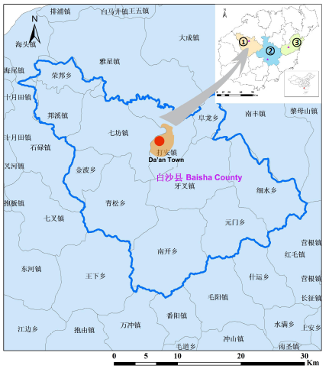
Figure L-5: Location map of Wuzhishan pig demonstration landscape
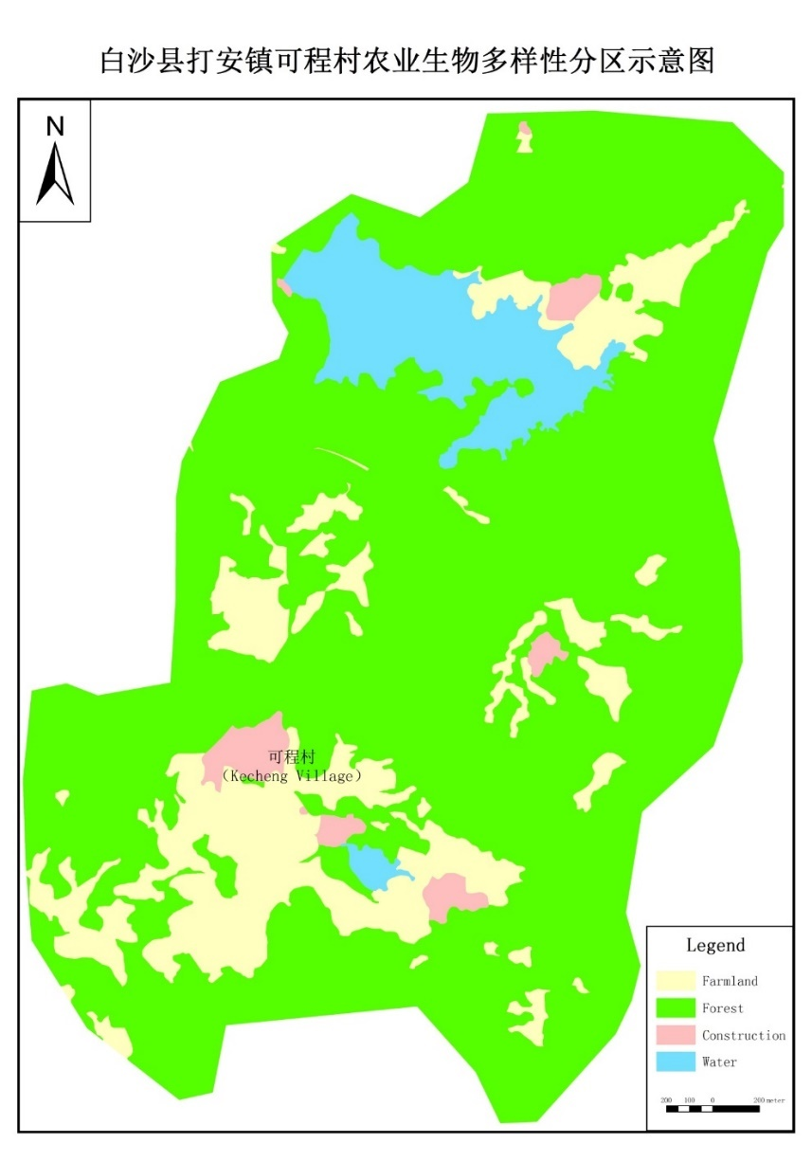
Figure L-6: Demonstration landscape map, Wuzhishan pig
Da’an township is located in the north-central part of Baisha County. It is connected to the county town of Yasha in the east and southeast, connected to Longlong Township to the northeast, connected to Zhangzhou City to the north, and connected to Qifang Township to the West. Da’an township has a tropical monsoon climate with high temperature and rain. It has 2,056 hours of sunshine annually, an average annual temperature of 21.9-23.4 °C, and an average annual rainfall of 1,725 mm. The terrain in the territory is dominated by hilly areas, and there are nine ridges and nine mountains in the east and south. The main river is the Zhubi River, which is the second largest river in the county. The township has 602.8 ha of agricultural land. The town has an area of 547.6 ha of arable land, including 369 ha of paddy fields, and 178.7 ha of dry fields. The main economic crops are rubber, sugar cane, rice and cassava. Among them, the rubber area has reached 3547.8 ha, the harvest area is 1,364.3 ha, and the total output is 2,028 tons. It is one of the major townships producing natural rubber in Baisha County. There is 4326 ha of forest land, 2333 ha of state-owned forest land, 4989 ha of collective forest land. forest coverage is 68% in township.

Diversity Status, Threats, Coverage and Nutritional and Cultural Values
Wuzhishan pig, also known as Wujiao pig, is a famous pig variety in China. Wuzhishan pigs are native to the Wuzhishan area where Li and Miao people live in the central part of Hainan Province. There is no exact written record of origin; the earliest record can be dated back to 2000 years ago when Ban Gu (班固) wrote about Li people on Hainan Island raising pigs in Han Shu (汉书)， but it is unknown whether the pigs were Wuzhishan pigs. There are three possible sources of Wuzhishan pig germplasms. (i) it was domesticated by ancient residents on Hainan Island from wild pigs independently. (ii) It is a result of deterioration from Xiaoerhua pig (小耳花猪). (iii) It is a product of hybrids of Xiaoerhua pig and wild pig. The fixed-point study shows that both pure and complex or hybrid utilization have the characteristics of genetic instability ⁶.
They used to be endangered as they were competed by commercial varieties of pigs and farmers had low desire of feeding the Wuzhishan pigs during 1980s. Later they were recovered through promotion by local governments and renewed demands by consumers. Currently, they are the country's second-class key protected animals. It has strong disease resistance. Wuzhishan pigs are small in size and have a compact constitution. The head is small and long, the ears are small and upright, and the mouth is pointed. The chest is narrow, the abdomen is not drooping, the limbs are thin and short, the hairs are mostly black or brown, there are white triangles or stripes on the forehead, the inside of the abdomen and limbs are white, and the bristles are black or brown. The temperament is slightly docile, responsive and good at running. The growth and development of Wuzhishan pigs are slow, and all growth indicators are lower than those of other small pigs. The reason for the dwarf is related to the long-term inbreeding of local wild boars and their own many genetic controls. According to the field survey of the Institute of Tropical Agricultural Sciences of China, Wuzhishan pigs are mainly distributed in the mountainous areas where ethnic minorities live in Qiongzhong, Baoting, Baisha, Changjiang and Sanya cities and counties in Hainan Province. Over 50 germplasms of Wuzhishan pigs are endangered.
The meat of Wuzhishan pigs is generally low in fat and has good taste characteristics. Few studies have been performed on nutritional quality of Wuzhishan pig. In central mountainous area of Hainan Island, it is popular to raise Wuzhishan pig. It is an important food in banquets when hosting guests and in festivals.

Institutional Arrangements associated with Sustainable Use of Agro-Biodiversity
Agencies at the levels of county and township are responsible for sustainable use of agro-biodiversity in different aspects for Wuzhishan pig. Mainly there are three agencies and government authorities involved in this work.
Institution | Roles
Animal Husbandry Bureau of Baisha County | Providing technical assistance; providing financial incentives.
Veterinary Station of Daan Township | Providing technical assistance; inspection of epidemic diseases
Government of Da’an Township | Providing financial incentives; collecting information of agricultural economy issues.

Incentive Mechanisms and Policies
There are non-financial incentives for Wuzhishan pig in Baisha. For example, in 2018, the government of Baisha County sponsored ten brands for special local products, called Top 10 Brands of Baisha (白沙十大品牌)， among which Wuzhishan pig was listed (here it is called Wujiao pig). The product of Wuzhishan pig produced by Fomian Mountain Breeding Cooperative was issued “China Green Environment Brand”. However, there is no financial incentive mechanisms available for promoting sustainable use of agro-biodiversity for this variety in Baisha.

Farmer Associations, Cooperatives and Private Sector Companies
There are 11 farmer associations and cooperatives engaged in Wuzhishan pig raising and sales. Fomian Mountain Breeding Cooperative in Baisha County is relatively big in scale, which is a potential cofinancing partners for this project.
Cooperative Name | Address | Manager
Heyou Breeding Professional Cooperative | Baisha County Rongbang Township Lingwei Village Committee | Chen Song
Shenhoushi Culture Professional Cooperative in Baisha County | Baisha County bangxi Nanban Village Committee | Chen Xiongjin
Dabing Beneficiaries Farming Professional Cooperative in Baisha County | Baisha County Qingsong Township Yash one Group | Zhang Kaiquan
Dabing Beneficiaries Farming Professional Cooperative in Baisha County | Baisha County Qingsong Township Yash one Group | Fu Lianmei
Yitiao Rich farmer Farming Professional Cooperative in Baisha County | Baisha County Qingsong Township Yitiao Village | Liu Ya
Shixi Village Cooperative in Baisha County | Baisha County Qingsong Township Shixi Village | Li Liangchang
Nanba Cooperative in Baisha County | Baisha County Qingsong Township Banan Village | Wang Jindi
Fomian Mountain Breeding Cooperative in Baisha County | Baisha County Xishui Township Ranch | Wu Weifu
Gaofeng Wujiao pig Cooperative in Baisha County | Baisha County Xishui Township Ranch | Liang Yonghao
Baisha County Ecological Ranch Cooperative | Baisha County Xishui Township Ranch | Wei Hui
Ecological Ranch Cooperative in Baisha County | Baisha County Xishui Township Ranch | Wei Rixin

Eco-certifications of Target Indigenous Variety or Landrace
Green Food label has been issued to Wuzhishan pig in Wuzhishan City. Baisha County is applying for this label, whose approval is being processed.

Current and Potential Market Demand
There was very serious market shrinkage of Wuzhishan pig in 1980s, and their demand has been slowly recovered since 1990s. During recent years, Wuzhishan pig has gained rapid growth in market, and its fame has been created even beyond Hainan Island. Currently, there is no mature supply chain, and restaurants and hotels in major cities tend to buy Wuzhishan pig directly from local farmers in Baisha. Currently there is no systematic commercial promotion activities. Pork of Wuzhishan pig is characteristic of low-fat content and unique taste, it is expected to gain much more market volume. However, erosion of germplasm and lack of epidemic prevention may pose negative impacts on supply. In recent years, there is a new demand of Wuzhishan pig as experimental animals for biological, medical and pharmaceutical research from universities, hospitals and research institutions. As Wuzhishan pigs have small bodies, which are superior to commercial pigs for medical and pharmaceutical research. The demand is expected to grow for these purposes.

Summary of Household Socioeconomic Surveys
As part of the project preparation phase, socioeconomic surveys were made in July 2018 at 25 households in the villages of Yada and Dahe in Baisha County, about 8% of the total. The results of the surveys are summarized below.
As part of the project preparation phase, socioeconomic surveys were made in November 2018 at 25 households in the village of Kecheng in Baisha County, about 1.7% of the total.
There are 329 households in Kecheng Village. The populations are all rural, who all engage in farming. All the people surveyed are Li people. 24 people surveyed are male, while 1 is female. People surveyed are between the ages of 28-67. Average household income is RMB ￥22080.00. 40.24% of average agricultural income is from agriculture, while income from Wuzhishan pig raising accounts for 59.76% of total agricultural income. Access to market relies mainly on cooperative and local self-marketing. Average access to farmland is 0.18 hectare. Poultry manure and farmyard manure are main source of fertilizer. Agricultural tricycles are the major agricultural equipment, and motorcycles are the major vehicles. Farmers mainly raise Wuzhishan pigs, ducks and chicken. 8 of people surveyed only got primary school education, and 4 got junior high school education. 14 people surveyed have received trainings. There is a village-level women’s association.
Village： | 2
Age(s)： | 28-67（25）
Household surveyed: | 25
Household total: | 329
Percentage: | 8%
Gender： | Male：24  Female：1
Ethnicity： | Li：25
Household income, annual in 2017, CNY: | Average：22080（25）  Min-Max：5000-38600（25）  Standard deviation：10699.53（25）
Agricultural household income, % of total： | Average：40.24（25）  Min-Max：13-100（25）  Standard deviation：17.20（25）
Proportion of total income from target variety, %： | Average：59.76（20）  Min-Max：0-87（20）  Standard deviation：17.20（20）
Annual output from target variety, in 2017： | Average：29.83（23）  Min-Max：8-100（23）  Standard deviation：20.70（23）
Access to markets for target varieties： | Local：17  Cooperative agency sales：7
Access to farmland, hectare： | Average：0.18（25）  Min-Max：0.01-0.4（25）  Standard deviation：0.09（25）
Type of land use arrangement： | Contract：22
Main agricultural outputs (kg)： | Wujiao Pig：  Average：29.17(23)  Min-Max：5-100(23)  Standard deviation：21.02(23)
Access to irrigation water resources： | Water irrigation：25
Improved soil fertility practices： | Fertilizer：1  Farmyard manure：10  Poultry manure：15  Organic Fertilizer：6  Soil fertilizer：1  Green manure：13
Problems with invasive species： | None
Agricultural equipment： | Tillage machine：1
Vehicles： | Motorcycle：16  Agricultural tricycle：9
Irrigation pumps： | None
Livestock (indicate type and numbers)： | Duck：40(2)  Cattle：1(1)  Chicken：39.62(13)  Wujiao pig：110.09(23)
Male | 0.96
Female | 1
Use of traditional varieties into regular diet： | Rice：25  Wild herbs：1
Education attainment： | Primary school：8  Junior high school：4  High school：13
Trainings received： | Breeding training：8  Farming training：4  Agricultural skills training：1
Membership in cooperatives, associations, etc.： | Farming cooperatives：16  Cooperative：4

Jiaji duck landscape profile

Physical Setting
The demonstration landscape for Jiaji duck is located in the Shibi Township (see Figure L-7). The demonstration landscape covers an area of 1,319 ha, as shown on Figure L-8. The demonstration landscape was delineated on the basis of an area where there is a prevalence of local farmers raising Jiaji duck – currently or in the past.
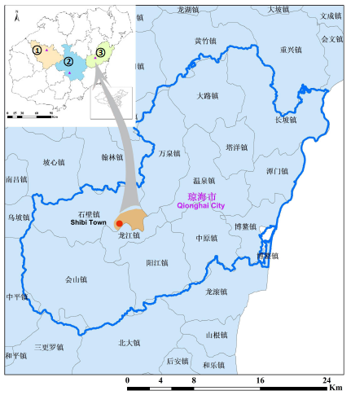
Figure L-7: Location map of Jiaji duck demonstration landscape
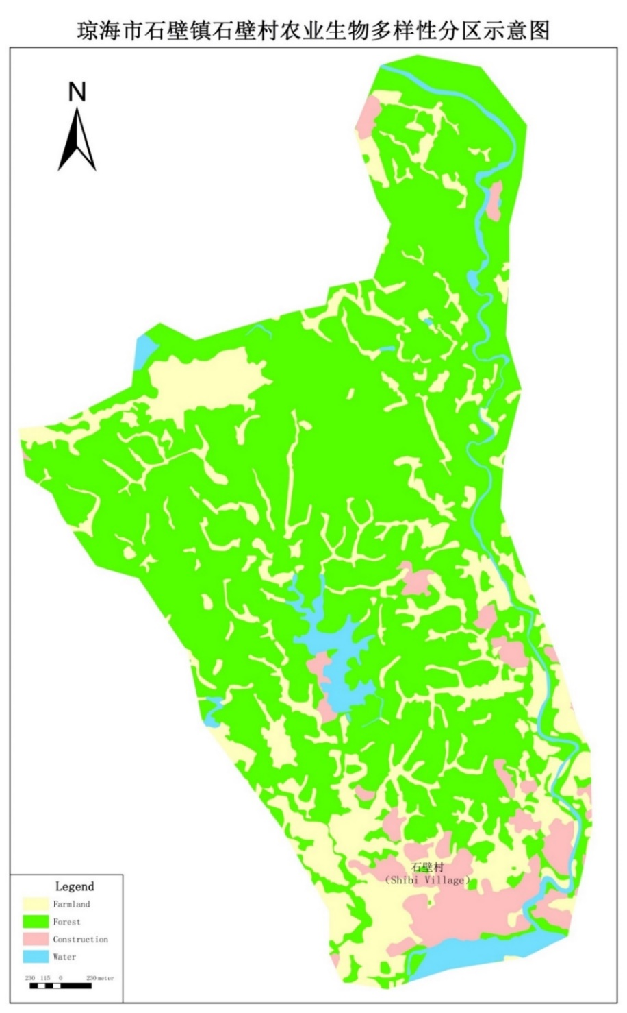
Figure L-8: Demonstration landscape map, Jiaji duck
Shibi Township is located on the north bank of the middle reaches of the Wanquan River in the southwest part of Qionghai City. It is adjacent to the counties of Ding 'an and Tunchang and to the state-owned Nanzhao farm, Dongtai farm, and Dingan county of Guoying Zhongrui farm. The township is surrounded by Wanquan township and Longjiang township of Qionghai City. It is a typical Golden Triangle zone.The central area of economic and cultural integration between the three cities (counties) and the four towns, the high concentration of people and logistics makes it an area of big influence on the southwest side of Qionghai City. With an area of 171 square kilometers and a population of 17,000, it has a tropical monsoon climate. The township has jurisdiction over 7 administrative villages, 77 natural villages, and 104 villager groups with a total population of 17,520 people ⁷.

Diversity Status, Threats, Coverage and Nutritional and Cultural Values
Jiaji duck, also known as Fan Duck (番鸭), serves as a well-known dish in Hainan. It is raised in east part of Hainan Island, and it is named after a township, called Jiaji Township, in Qionghai City, Hainan Province. Local people believe it was brought from Southeast Asia about 300 years ago. It is featured with red coronet, yellow web and white and black feather. It is fed by a unique feeding method called Tian Ya (填鸭), and as a result, the ducks turn to big chest, thin skin, soft bones and delicate meat. It represents a unique germplasm of duck in China. Few studies have been performed on Jiaji Duck germplasms and their genetic background. Over recent years, market of Jiaji duck has been shrinking, as farmers are more willing to raise commercial varieties of duck. As a result, there is serious loss of genetic diversity.
Few studies have been carried out on nutritional value of Jiaji duck. It represents a unique germplasm of duck in China, and thus has potential value in duck breeding.
Some households raise Jiaji duck for their own consumptions. A farm raises ducks, including Jiaji duck for commercial purposes, but it is unknown how many Jiaji ducks are raised and sold annually.

Institutional Arrangements associated with Sustainable Use of Agro-Biodiversity
Agencies at the levels of county and township are responsible for sustainable use of agro-biodiversity in different aspects for Jiaji duck. Mainly there are three agencies and government authorities involved in this work.
Institution | Roles
Animal Husbandry Bureau of Qionghai City | Providing technical assistance; providing financial incentives.
Veterinary Station of Shibi Township | Providing technical assistance; inspection of epidemic diseases for Jiaji ducks.
Government of Shibi Township | Providing financial incentives; collecting information of agricultural economy issues.

Incentive Mechanisms and Policies
As one of the Four Famous Dishes of Hainan (海南四大名菜), Jiaji duck is an important brand for Qionghai City. Qionghai City Government is trying to popularize Jiaji duck and sponsor cooperatives to develop business. However, there are no current financial incentive programs for Jiaji duck to farmers, cooperatives, companies, etc. in Qionghai City.

Farmer Associations, Cooperatives and Private Sector Companies
There are 5 farms and 2 private companies raising Jiaji duck and doing related business, among which three are located in Tayang Township. In Shibi Township, although farmers raise Jiaji duck, and there is a farm raising ducks, there is no farm, cooperative or company officially registered within the township.
Township | Cooperative name
Tayang Township | Hainan Chuanwei Muscovy Duck Breeding Co., Ltd.
Wanquan Township | Qionghai Quanxin  Jiaji Duck Farm
Jiaji Township | Qionghai Yinyi  Jiaji Duck Farm
Tayang Township | Qionghai Minqiong Breeding Poultry Company
Bin Village Economic Zone | Huang Chuanxin  Jiaji Duck Farm
Yangjiang Township | Wang Jian Jiaji Duck Farm
Tayang Township | Huang Guangyue Jiaji Duck Farm

Eco-certifications of Target Indigenous Variety or Landrace
Currently there is no eco-certification for Jiaji duck in Shibi Township, in Qionghai City or in other territory of Hainan Province. There used to be geographic brand for Jiaji duck, but it was cancelled for unknown reason. Qionghai City Government has shown interests on apply for a geographic brand for Jiaji duck, but no specific steps have been pursued.

Current and Potential Market Demand
Jiaji duck is characteristic of thick meat, thin skin, soft bones and little fat, in contrast to usual commercial duck. It is welcome in local markets in Qionghai and other areas of Hainan Province. However, due to sophisticated and high-cost raising, it is currently facing competition from other ducks. Conservation of germplasms of Jiaji duck is complicated, and there is loss and erosion of the germplasm of Jiaji duck. There is oversupply of Jiaji duck in the market. It is difficult to predict its potential market demand. In market, it is common that other ducks are pretended to be Jiaji duck, and it is difficult to discriminate Jiaji duck from other ducks when they are sold as meat, but they taste different which can be told by experienced consumers. This situation has hampered development of a healthy and sustainable market of Jiaji duck. In recent years, prices of Jiaji ducks fluctuate violently, which strike enthusiasms of farmers to some extent.

Summary of Household Socioeconomic Surveys
As part of the project preparation phase, socioeconomic surveys were made in July 2018 at 20 households in the natural villages of Shibi, Nanxing and Shuangfeng Villages, Qionghai City, about 1% of the total households.
There are 690 households in Shibi Township. The populations are all rural, who all engage in farming. Among the people surveyed, 2 are Li people and 18 are Han people. 7 people surveyed are male, while 13 are female. People surveyed are between the ages of 33-68. 5 Households engage in raising of Jiaji ducks. Average household income is RMB ￥14227.27. 40.48% of average agricultural income is from agriculture, while income from Jiaji duck raising accounts for 60% of total agricultural income. Access to market relies mainly on local self-marketing. Average access to farmland is 1.36 hectare. Paddy field is the major land using for crop planting. Both farm manure/organic fertilizer and chemical fertilizer are sources of fertilizer. Tractor and pumping machine are the major agricultural equipment. Farmers raise ducks and chicken, and some also raise pigs and gooses. 15 and 4 got junior high and high school education, respectively. Most people surveyed have received trainings, mostly on farming techniques. There is a village-level women’s association. 3 households have access to low interest credit. 1 household has access to agriculture insurance.
Village： | 3
Age(s)： | 33-68
Household surveyed: | 20
Household total: | 690
Percentage: | 16%
Gender： | Male：7  Female：13
Ethnicity： | Li：2  Han：18
Household income, annual in 2017, CNY： | Average：14227.27（21）  Min-Max：3000-30000（21）  Standard deviation：12101.58（21）
Agricultural household income, % of total： | Average：40.48（20）  Min-Max：0-100（20）  Standard deviation：21.21（20）
Proportion of total income from target variety, %： | Average：0.6（19）  Min-Max：0-10（19）  Standard deviation：2.2（19）
Annual output from target variety, in 2017： | Average：21.2（19）  Min-Max：0-50（19）  Standard deviation：16.66（19）
Access to markets for target varieties： | Local：16  Local county：2  Not sell：1
Access to farmland, hectare： | Average：1.36（20）  Min-Max：0.0897-19（20）  Standard deviation：3.96（20）
Type of land use arrangement： | Paddy field：13  Rubber：5  Areca：2  Contract：2  Rice：3
Main agricultural outputs (kg)： | Average：1464.71（16）  Min-Max：100-8500（16）  Standard deviation：1989（16）
Access to irrigation water resources： | Water conservancy：16  Reservoir：2
Improved soil fertility practices： | Farm manure/Organic fertilizer：5  Chemical fertilizer：15
Problems with invasive species： | Aeroplane grass：18
Agricultural equipment： | Tractor：2  Pumping unit：1
Vehicles： | Motorcycle：19  electric vehicle：5  Car：1
Irrigation pumps： | Irrigation pumps：1
Livestock (indicate type and numbers)： | Chicken：18  Duck：19  Goose：6  Pigs：8  Rabbit：1
Male | 1
Female | 1.1
Use of traditional varieties into regular diet： | Rice：19  Vegetables：14  Meat：13
Education attainment： | High school：4  Junior high school：15  Primary school：3
Trainings received： | Epidemic prevention training：1  Farming：10  Agricultural skills training：1  Rice training：2  Cricket agricultural training：1
Membership in cooperatives, associations, etc.： | Farming and planting cooperatives：2
Women or ethnic minority groups： | No
Access to low interest credit： | 3 households,total 52000
Agriculture insurance： | 1 households,total 2500

References
- https://baike.baidu.com/item/%E4%B8%8A%E5%AE%89%E4%B9%A1/2971082?fr=aladdin
- https://baike.baidu.com/item/%E6%89%93%E5%AE%89%E9%95%87
- 陈志国，倪根金，周华 （2018）海南黎族山兰稻的历史、价值及保护利用。广西民族大学学报（哲学社会科学版）40（4）：82-87.
- 黄春燕，罗文启，王波，杨小波 （2015）海南中南部地区旱稻(山兰稻)种质资源及保育模式。广西植物 35（6）：905-912.
- 袁楠楠，魏鑫，薛达元，杨庆文 （2013） 海南黎族聚居区山栏稻的起源演化研究。
- Cai et al., Study on Identification of Hainan Special Wild Boar by DNA Barcoding, China Animal Husbandry & Veterinary Medicine 2018,45(05),1283-1288
- https://baike.baidu.com/item/%E7%9F%B3%E5%A3%81%E9%95%87/1926340

